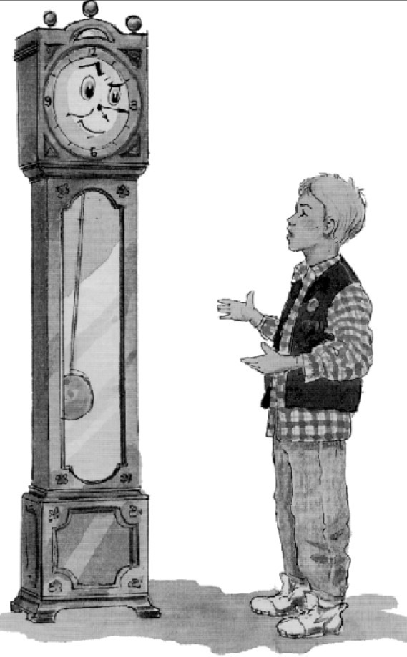
1.
TIME TROUBLE
In the first part of Time Trouble by Penelope Lively, a boy
meets a talking grandfather clock, only to find that this leads to
some unexpected events.
When I was nine I came to an arrangement with a grandfather clock; it was disastrous. Never trust a clock. Believe me – I know. I’ll tell you about it.
I was in the hall of our house, all by myself. Except for the clock. I’d just come in from school. The clock said ten past four. And I said, out loud, because I was fed up and cross as two sticks, ‘I’d give anything to have this afternoon all over again.’
‘Would you now,’ said a voice. ‘That’s interesting.’
There was no one there. I swear. The voice came from the clock. I looked it in the eye and it looked back, the way they do. Well, they’ve got faces, haven’t they? Faces look.
‘I deal in time, as it happens,’ the clock went on. ‘Had some bad time, have you?’
I nodded.
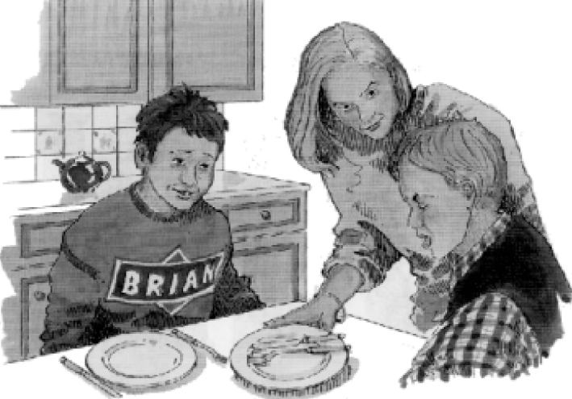
‘Sometimes,’ said the clock, ‘I can lend a hand.’ It twitched one, from eleven minutes past four to twelve minutes past. ‘Tell me all, then.’
So I told about how at dinner I was in a bad mood because of having a fight with Brian and when Mum kept going on at me about something I kept thinking, ‘Oh, shut up!’ only unfortunately what was meant to be a ‘think’ got said out loud accidentally, so then Mum was in a very bad mood indeed with me and I got no pudding. And then on the way back to school Brian and I had another fight and my new pencil case got kicked into a puddle and all dirtied over. And we were late and Mrs Harris told us off. And on the way home we had an argument resulting in me falling over and my pocket money dropping out of my pocket and ten pence getting lost.
‘Tough,’ said the clock. ‘I see what you mean. Well – here’s a deal. You have this afternoon back and I’ll have next Wednesday.’
‘Next Wednesday?’
‘Next Wednesday. Your next Wednesday afternoon.’
‘But I don’t know yet what’s going to happen next Wednesday,’ I objected.
‘Quite,’ said the clock. ‘It’s a risk. Well – take it or leave it.’
I thought. What’s one Wednesday afternoon, out of all the Wednesday afternoons you’ve got? I mean, on the whole one Wednesday afternoon’s much like another.
‘OK,’ I said. ‘And I have this one again?’
The clock made its whirring noise for quarter past four. ‘That’s right, my lad. See if you can make a better job of it.’
Here we go again ...
You’re not going to believe this. There I was at dinner all over again, in a bad mood just like before, only this time when Mum started going on at me I didn’t say anything. I just sat. And then somehow, accidentally, my leg shot out and it kicked Brian and Brian yelled and his milk got spilled and Mum got in a proper temper and not only did I get no pudding, but I got no seconds either. On the way back to school I thought. Right ... And when Brian started trying to trip me up I didn’t trip back but I started running on ahead. And a paving stone got in my way and I fell over and my new pencil case went into the road and a car went over it and all the pencils were broken and the biro with six colours was bent so it wouldn’t work any more. And when the bell went I was so fed up I went into the corner shop for some chocolate. And you’re not going to believe this. My money had all gone out of my pocket. Twenty-eight pence from last Saturday. It must have dropped out when I fell over before.
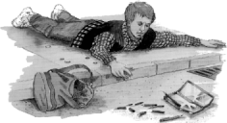
There I was in the hall again. With the clock. Furious. I said, ‘It was worse. I want the first one back again. That way, at least I’d have my money and the pencils and the biro with six colours.’
‘No way,’ said the clock. ‘A deal’s a deal.’ And it just stood there, ticking. That was all it did for the next five days.

Third time lucky
I wondered what would happen, when it came to Wednesday. What happened was this. Brian and I came home from school for dinner, just as usual. We ate it, just as usual. Mum said, ‘Off you go, boys,’ just as usual. We started getting our anoraks. The phone rang. The clock struck one. Mum said, ‘Wonder who that is ...’ She went to answer the phone.
...And the next thing I knew the clock was striking seven and I was in the kitchen again looking at a plate of supper that I didn’t want. I felt a bit sick.
I said, ‘I feel a bit sick.’
‘I’m not surprised,’ said Mum.
‘You shouldn’t have had the peach melba bombe as well as the vanilla with chocolate sauce. And three helpings of chips!’ said Brian.
I looked at him.
An awful, suspicious feeling began to creep over me.
Brian was talking about something else now. ‘Remember the bit when the spaceships all started crashing into each other? That was fantastic. And when the robots all came out of the volcano?’
Mum had gone out of the back door for something. I thought hard. I said, cautiously, ‘What sort of an afternoon was it, would you say?’
‘What sort of an afternoon!’ cried Brian. ‘It was just amazing! Well, you were there, you dope! I mean, it’s not just any old afternoon that Uncle Jim suddenly rings up and says he’s over this way and he’d like to take us out and he talks Mum into letting us miss school and he comes in his new sports car with the roof down all the way and... Well, you were there. Hey – remember the bit in the cartoon when they all fell over the cliff!’
I swallowed. ‘Yeah ... Sure.’ After a moment I said, ‘It was Space Victory, was it, the film?’

He stared at me. ‘Course it was Space Victory, idiot. Space Victory, what we’ve been wanting to see for years. Remember the bit when ...’
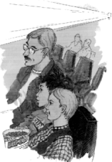
‘Course,’ I snarled through clenched teeth.
I went out into the hall, banging the door. I stood in front of the clock.
‘Did you know?’ I demanded.
‘What’s that?’ said the clock, bland as you like.

‘Did you know that it wouldn’t just be an ordinary school afternoon? Did you know Uncle Jim would come... and... Space Victory...three helpings of chips...’ I spluttered. I couldn’t go on.
The clock ticked away, evasive. ‘I said it would be a risk, didn’t I? Funny stuff, time. Doesn’t always do to mess about with it.’
‘It was your idea,’ I said sulkily.
‘Look,’ said the clock. ‘I was just going about my normal business, dealing in time. If you don’t like what’s in the paper you don’t complain to the newsagent, do you?’
I glared at it.
‘I just keep track of it, right? See it’s moving along at the proper rate, all that kind of thing. One bit’s the same as another, as far as I’m concerned. The quality’s your problem – doesn’t interest me.’
I said, ‘I want my Wednesday afternoon back.’
© Time Trouble from Uninvited Ghosts by Penelope Lively, published by William Heinemann
Illustrations by D Leithead.

QUESTIONS
2. Time Trouble
Look at the story Time Trouble in your reading booklet.
Put a ring around the word or group of words that completes the sentences
1. The first time the grandfather clock spoke to the boy was one afternoon. He had been feeling
A. .
1 mark
2. This was because that afternoon had been so full of
B. .
1 mark
3. The boy was surprised to hear the clock speak but he was sure that it had spoken because
C. .
1 mark
4. He told the clock all about his awful afternoon.
Among other things, he described the fight with Brian, being cheeky to their mother, the loss of the ten pence and getting into trouble with Mrs Harris. Mrs Harris was his
D. .
1 mark

5. In fact, the afternoon had been so bad that he wished to have it back to see if
E. .
1 mark
6. Surprisingly, the clock suggested making a deal and allowed the boy to relive that afternoon. In return, he had to
F. .
1 mark
7. No one, not even the clock, could have guessed that the boy’s second chance to live through that afternoon would be
G. .
1 mark
8. All in all, for the boy, this deal turned out to be rather
H. .
1 mark
9. Answer this question about what happened in the story.
Write down three ways in which the second afternoon.
(Here we go again ...,) was different from the first afternoon.
1. .............................................................................................................
......................................................................................................................
2. .............................................................................................................
......................................................................................................................
3. .............................................................................................................
......................................................................................................................
3 marks
10. (a) Why did the boy think it was a risk to lose the next Wednesday afternoon?
.............................................................................................................
.............................................................................................................
.............................................................................................................
1 marks
(b) Why do you think he decided to take the risk?
.............................................................................................................
.............................................................................................................
.............................................................................................................
1 marks
11. What was the boy thinking as the awful, suspicious feeling began to creep over him? (Third time lucky)
......................................................................................................................
......................................................................................................................
......................................................................................................................
2 marks
12. Write down three different things that Brian enjoyed on the afternoon when their uncle took the boys out.
1. .............................................................................................................
2. .............................................................................................................
3. .............................................................................................................
3 marks
13. Find two words from the story that show that Brian enjoyed the afternoon with his uncle.
1. ............................................ 2. ...........................................
2 marks
14. In describing the first two afternoons, the author starts many sentences with And...
Why do you think the author chose to do this?
......................................................................................................................
......................................................................................................................
......................................................................................................................
1 mark

15. The boy could not remember his exciting afternoon with Uncle Jim and was in a bad mood because of this.
Find four words or phrases from the story that show his bad mood
1. ............................................ 3. ...........................................
2. ............................................ 4. ...........................................
4 marks
16. What does the clock mean when it says it just keeps track of time and is not interested in the quality? (at the end)
......................................................................................................................
......................................................................................................................
......................................................................................................................
1 mark
17. Did the boy get on well with his brother, Brian?
Yes No
Explain your reasons, using parts of the story to help you.
......................................................................................................................
......................................................................................................................
......................................................................................................................
......................................................................................................................
......................................................................................................................
3 marks
18. Would you like the clock as a friend?
Yes No
Explain your reasons, using parts of the story to help you.
......................................................................................................................
......................................................................................................................
......................................................................................................................
......................................................................................................................
......................................................................................................................
3 marks

19. The boy asks for the last Wednesday afternoon back (at the end).
Do you think the clock will give it back?
Yes No
What makes you think this? Explain your reasons, using parts of the story to help you.
......................................................................................................................
......................................................................................................................
......................................................................................................................
......................................................................................................................
......................................................................................................................
3 marks
20. Would you be interested in reading the rest of the story?
Yes No
Say what you liked or did not like about the story so far.
......................................................................................................................
......................................................................................................................
......................................................................................................................
......................................................................................................................
......................................................................................................................
3 marks

