CAT
Judith Nicholls
My cat’s tail  can dance or beckon  whilst he sleeps,  can wave or threaten,  fall or rise. | 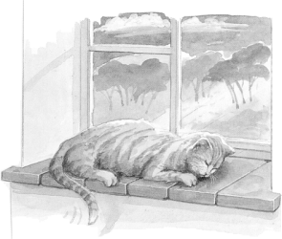
Warily
it lies awake,
all on it’s own;
he wakes,
it lies forgotten.
It lies alone,
quite separate -
or so it seems.
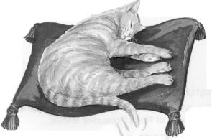 | Could it be the place  where, secretly,  his life goes on?  A space to hide for ever  a million catty dreams?
© Judith Nicholls 1987, from Midnight Forest by Judith Nicholls, published by Faber & Faber
and reprinted here by permission of the author

. These questions are about the poem Cat.
1. What part of the cat is the poem about?
......................................................................................................................
1 mark
2. What happens when the cat is asleep?
1 mark
3. Find and copy three words from the first verse that tell you how its tail moves.
1 ..................................................................................................................
2 ..................................................................................................................
3 ..................................................................................................................
1 mark
4. Warily
it lies awake,
all on its own;
Explain what these lines in the second verse mean.
......................................................................................................................
......................................................................................................................
......................................................................................................................
2 marks
5. Look at the last verse.
Explain what the author thinks the cat’s tail could be for.
......................................................................................................................
......................................................................................................................
2 marks
6. Why do you think the poem ends with two questions?
......................................................................................................................
......................................................................................................................
2 marks
7. Did the poem make you think differently about cats?
Explain your answer.
......................................................................................................................
......................................................................................................................
......................................................................................................................
2 marks

There’s a Fire in the Forest
There’s a fire in the forest!
The creatures are fleeing
The flames close behind
With the wind driving onward.
From underbrush up to
The high moving tree-tops
The fire’s surging forward.
There’s a fire in the forest;
The whole woods are burning.
The whole world is burning!

The creatures are seeking
The safety of streams
Beyond the hot burning.
The creatures are fleeing;
They are labouring, straining
To reach the cool river
They know just beyond them,
To escape the fierce burning,
To reach the cool stream
For which they are yearning.
by W.W.E. Ross
with permission of Mary L. Hutton.

4. These questions are about the poem There’s a Fire in the Forest.
1. In the poem, what are the forest animals:
a) escaping from?
......................................................................................................................
1 mark
b) looking for?
......................................................................................................................
1 mark
2. Find two verbs in the poem that suggest movement.
Write one word next to each dot.
- ...............................................................
- ...............................................................
1 mark

3. What is the main idea of the second verse of the poem?
Tick the best answer.
the speed and heat of the fire
the size and depth of the river
the fear and urgency of the animals
the thirst and hunger of the animals
1 mark
4. How has the feeling of panic been created in this poem:
a) in the choice of words? .......................................................................
......................................................................................................................
1 mark
b) in the way the lines are written? ...........................................................
......................................................................................................................
1 mark

